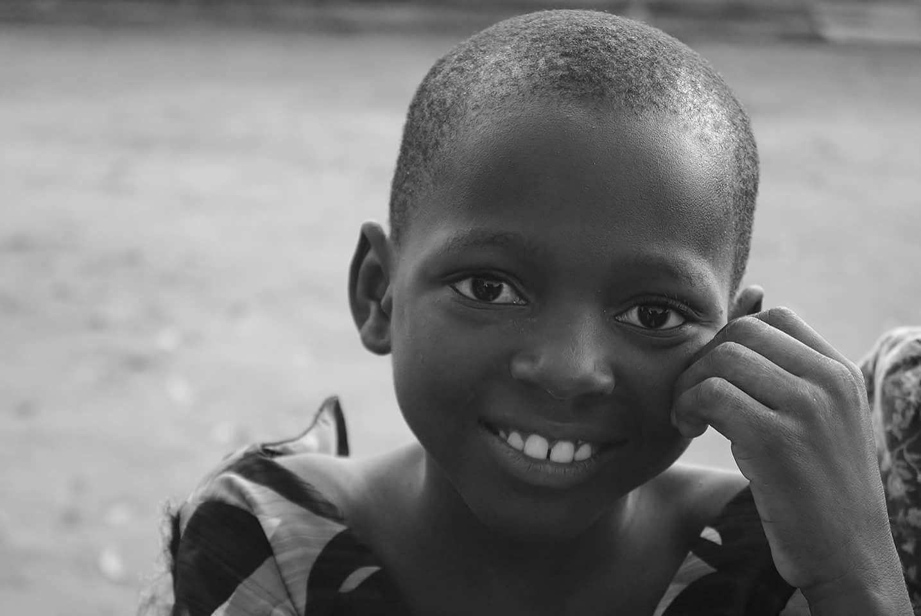  BAZA EDUCATION ACADEMIC YEAR 2015-2016 REPORT  BazaBaza Corporation, a 501(c) charitable organization simply Baza-education promotes quality education and life coaching for the under-privileged across Africa. A specific action has been taken since 2012 in Togo through the implementation of after-school tutoring program in seventeen villages of the country. Here is the report of our activities for the year 2015-2016 as pertained to the use of the fund received through Global Soul International  Thank you for making this program possible |  | Outline  BAZA-EDUCATION  2015-2016 TUTORING ACTIVITIES in TOGO  2015-2016  OTHER SUPPORTS  CLASS PASSING RATES  FINANCIAL REPORT  Baza education  PO Box: 90637  Nashville  Tennessee 37209  www.bazabazacorporation.org

I- Baza-Education Activities 2015-2016 sponsored by GSI

Baza Education officially opened classes on Saturday January 30, 2016 in its localities in Togo. The tutor’s orientations and training session have been held the weekend before; it was a successful event. We chose our new students in exam classes based on the report card of 2015; also we had the assistance of teachers who provided us with the list of students in need both academically and financially in 2016.
A special attention has been given to the students who are in exam classes and preparing for state examinations (BEPC, PROBATOIRE and BACCALAUREAT)
The local committee distributed school supplies to our orphan’s students.
During the year our tutors had taught every Saturday for 5 hours and every Wednesday afternoon for 2 hours. They also provided one on one tutoring and coaching with the students that had been identified as falling behind in their academics.
Our classes were closed right before state exam on June 13, 2016 and the results of the exam were in at the end of July 2016. The money provided by GSI was used to pay for 18 tutors, 6 coordinators, and schools supplies for 261 students in 6 villages.
II- Other supports that was provided to the students
Our actions are not for academics only. We have tried to address some social needs include free distribution of school kits, medical assistance and nutrition assistance.
- School kits: With the money provided by GSI, we gave out school kits, uniforms, shoes and other basics necessities, school supplies, uniforms, shoes and more.
- Medical assistance: We have been able to help the orphanage CEHBED for medical visit though ASET (a charitable medical organization in Togo) to Kpalime. All the students had a dental and eye examinations. The money given by GSI was used to pay for the transportation for our students to the medical examination.
- Nutrition: Malnutrition and lack of basic hygiene in School environment in Togo are also part of the problem. It is hard for a student who does not feed to learn. This year we received a gift of 25 bags of 100 lbs. and we used some the money provided by GSI to ship them to 17 villages to be distributed to our students.

III- Class Passing Rates

Here is our students result at the state examination for the year 2015-2016 for the localities sponsored by GSI

 | Villages | Number of students | Success Rates
1 | Adakpame | 36 | 100%
2 | Adetsikope | 44 | 100%
3 | Cacaveli | 67 | 100%
4 | Dalave | 34 | 100%
5 | Sagbado | 34 | 100%
6 | Mandouri | 46 | 98%
 | Total | 261 | 99.66 %

VI- FINANCIAL REPORT

SALARY & ALLOWANCES
ITEMS | QUANTITY | MONTHLY COST | ANNUAL COST (5 months)
Tutors($12/Month) | 18 | $ 216.00 | $ 1,080.00
Coordinators($20/Month) | 6 | $ 120.00 | $ 600.00
Local Committee Administrative Cost |  |  | $ 241.00
TOTAL |  | $ 336.00 | $ 1,921.00

ACADEMIC SUPPORT & OTHER EXPENSES
ITEMS | QUANTITY | COST
School Supplies for Baza- students |  | $ 182.00
Medical Trip to Kpalime |  | $ 66.00
Sandals for Baza-strudents | 78 | $ 75.00
Food distribution in the villages Transportation | 17 | $ 97.00
Printing and Photo copy for Academic use |  | $ 236.00
Miscellaneous |  | $ 45.00
TOTAL |  | $ 701.00

COMBINED TABLE
ITEMS | COST
Tutors($12/Month) | $ 1,080.00
Coordinators($20/Month) | $ 600.00
Local Committee Administrative Cost | $ 241.00
School Supplies for Baza- students | $ 182.00
Medical Trip to Kpalime | $ 66.00
Sandals for Baza-students | $ 75.00
Food distribution in the villages Transportation | $ 97.00
Printing and Photo copy for Academic use | $ 236.00
Miscellaneous | $ 45.00
GRAND TOTAL | $ 2,622.00

We are so lucky to have you as a donor. Thank you for investing in our organization and in the students we serve. Your generous gift went to good use. Because of you, we have been able to serve orphans and underprivileged kids in Togo, and provide them a loving, nurturing, and healthy environment to learn and study. Thanks to GSI, Africa will have a smarter, well-trained and honest workers and leaders. May the Almighty God bless you, your team and your Organization. We are so grateful and looking forward to work with you next year

