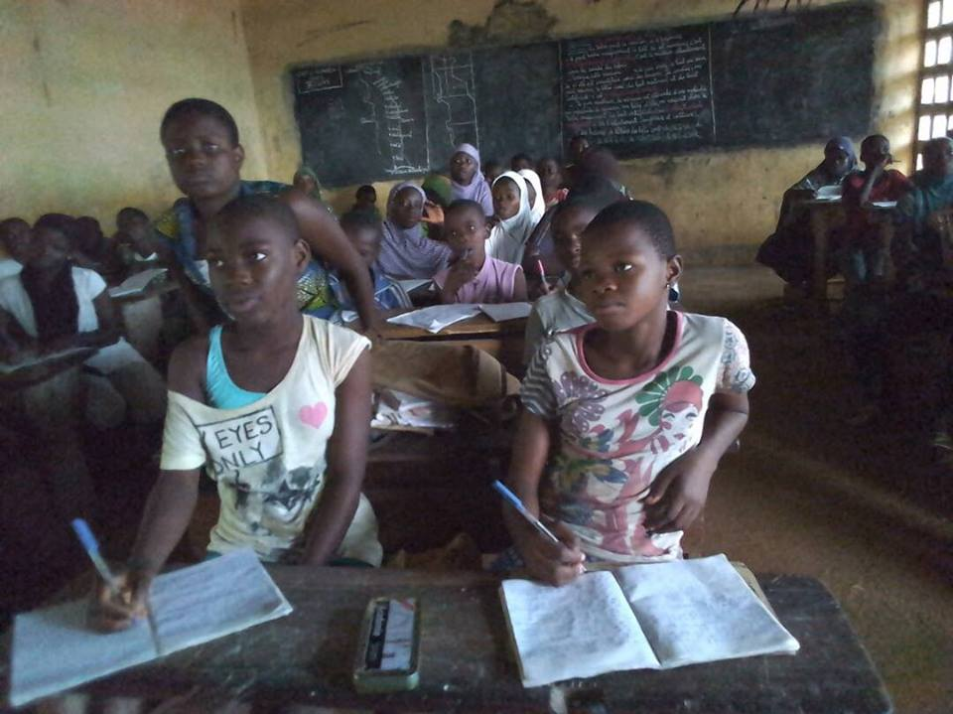  BAZA EDUCATION ACADEMIC YEAR 2016-2017 REPORT FOR GSI  BazaBaza Corporation, a 501(c) charitable organization simply Baza-education promotes quality education and life coaching for the under-privileged across Africa. A specific action has been taken since 2012 in Togo through the implementation of after-school tutoring program in different parts of the country. Here is the report of our activities for the year 2015-2016 as pertained to the use of the fund received through Global Soul International  Thank you for making this program possible |  | Outline  BAZA-EDUCATION  2016-2017 TUTORING ACTIVITIES in TOGO  2015-2016  OTHER SUPPORTS  CLASS PASSING RATES  FINANCIAL REPORT  Baza education  PO Box: 90637  Nashville  Tennessee 37209  www.bazabazaprojects.org

I- Baza-Education Activities 2016-201 sponsored by GSI

Baza Education officially opened classes on Wednesday February 1st, 2017 in its localities in Togo. The tutors’ orientation and training session have been held on Saturday January 28th, 2017; it was a successful event. We chose our new students in exam classes based on the report card of 2015; also we had the assistance of teachers who provided us with the list of students in need both academically and financially in 2017.
A special attention has been given to the students who are in exam classes and preparing for state examinations.
The local committee distributed school supplies to our students.
During the year our tutors had taught every Saturday for 5 hours and every Wednesday afternoon for 2 hours. They also provided one on one tutoring and coaching with the students that had been identified as falling behind in their academics.
Our classes were closed right before state exam on July 11, 2017 and the results of the exam were in at the end of August 2016. The money provided by GSI was used to pay for the tutors, coordinators, and schools supplies for ten villages.
II- Other supports that were provided to the students
- School kits: With the money provided by GSI, we gave out school kits, uniforms, shoes and other basics necessities, school supplies, uniforms, shoes and more.
- Our students had a chance to learn this year about crafting during the summer Break. Add pretty beads to a shoe or a bag. Now they are making a little money on their own on the village market days. We used some of the GSI money to pay the craft instructors. I will include the images of the products that our students made during their classes.
- We have 5 High school graduates from our programs that will be our new tutors next years. They will give back to a program that had helped them all this years.
- We have signed a partnership with Hope Commission, a charitable orgnization that teach visited
III- Exam Class Passing Rates

Here is our students result at the state examination for the year 2016-2017 for the localities sponsored by GSI. This year the government added one more month to the school years.

 | Villages | Number of students | Number of Succeeded Students | Success Rates
1 | Adakpame | 30 | 30 | 100%
2 | Adetsikope | 40 | 39 | 99%
3 | Cacaveli | 45 | 45 | 100%
4 | Dalave | 70 | 70 | 100%
5 | Sagbado | 34 | 34 | 100%
6 | Kara | 72 | 70 | 93%
7 | Blamakondji | 34 | 34 | 100%
8 | Djagble | 12 | 12 | 100%
9 | Kouma Konda | 14 | 14 | 100%
10 | Kouma Tokpli | 17 | 17 | 100%
 | Total | 368 | 365 | 99.20 %

VI- FINANCIAL REPORT

SALARY & ALLOWANCES
ITEMS | QUANTITY | MONTHLY COST($) | ANNUAL COST (6 months)
Tutors ($15/Month) | 20 | 300.00 | 1800.00
Coordinators ($20/Month) | 9 | 180.00 180.00 | 1080.00
TOTAL |  | 480.00 | 2880.00

BAZA EDUCATION TUTORING EXPENCES
ITEMS | COS($)
Tutors ($12/Month) | 1800.00
Coordinators ($20/Month) | 1080.00
Local Committee Administrative Cost | 181.50
School Supplies for Baza- students | 182.00
Printing and Photo copy for Academic use | 180.00
Craft Courses fees | 56.25
Miscellaneous | 78.00
GRAND TOTAL | 3557.75

Our Students are expressing their deepest thanks for your recent donation to Baza Education. Generous actions from organization like Global Soul International provide the financial and moral support needed to continue our mission.
With your faithful financial contributions over the years, you’ve demonstrated your deep commitment to our work of promoting a quality education in Togo.
Your support has repeatedly played a key role in our success in financing Baza Education in 10 villages--reducing illiteracy and multiple repeat of exam classes.
There is no way to fully express our gratitude for your loyalty. We at Baza Education are continually inspired by the dedication and generosity of donors like Global Soul International, who answer the call to give again and again. Stay Bless forever

